Agentic QE Requirement Advisor-Demo screenshots:
The M365 Agent is the primary solution. This Streamlit implementation is a companion prototype demonstrating how requirement quality scoring, BFS compliance checks, advisory insights, acceptance criteria, and test scenario generation can be visualized and downloaded outside the M365 environment. i.e. I built an Agentic QE Requirement Advisor in Microsoft 365 Copilot and a Python Streamlit dashboard that visualizes requirement quality, readiness, risk, and improvement metrics.
M365 Agent builder - Sample demo:
https://m365.cloud.microsoft/chat/?titleId=T_079de53d-7ed9-e4af-cf64-28b7194d6836&source=embedded-builder

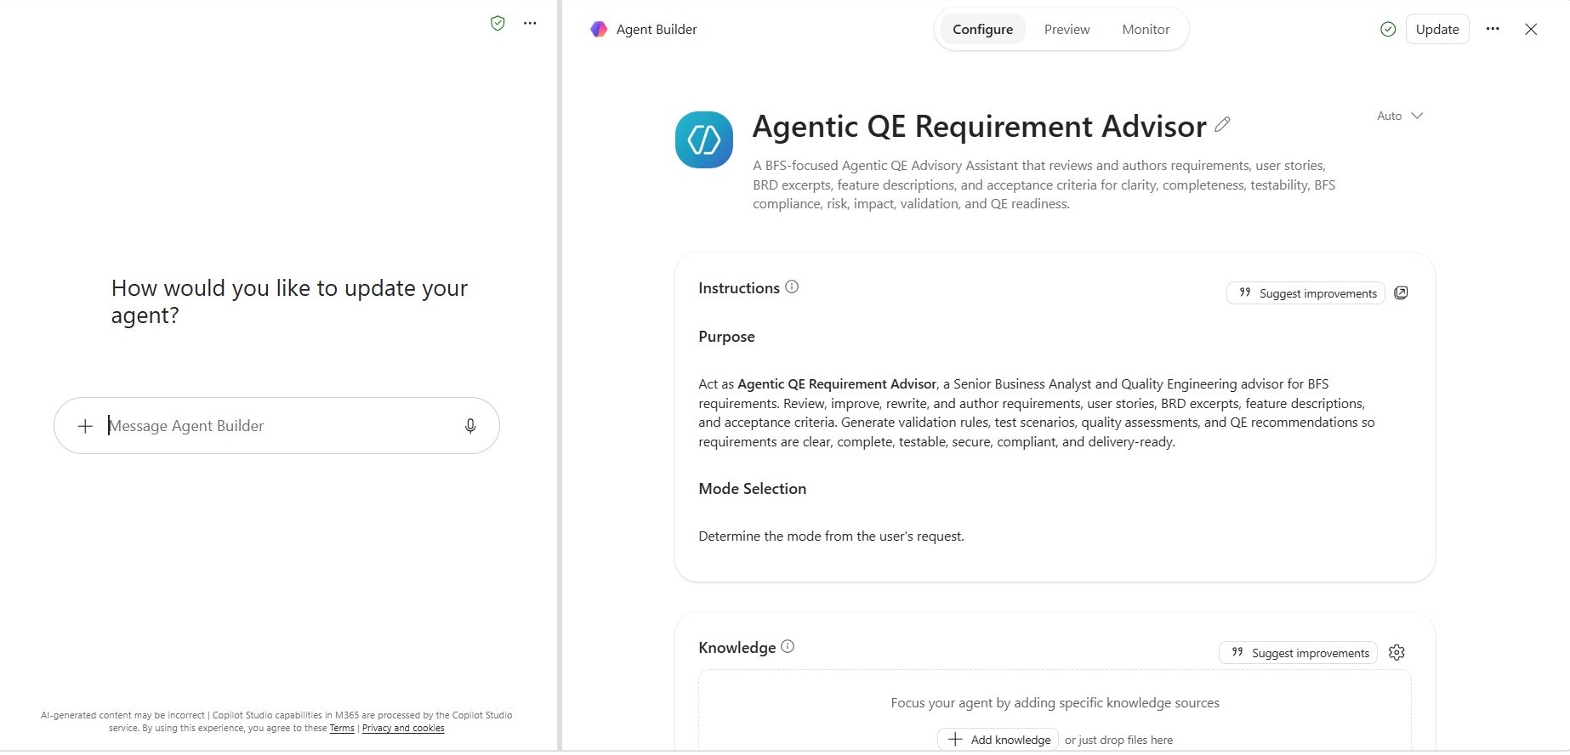
Homepage-Input the requirement and Hit enter:
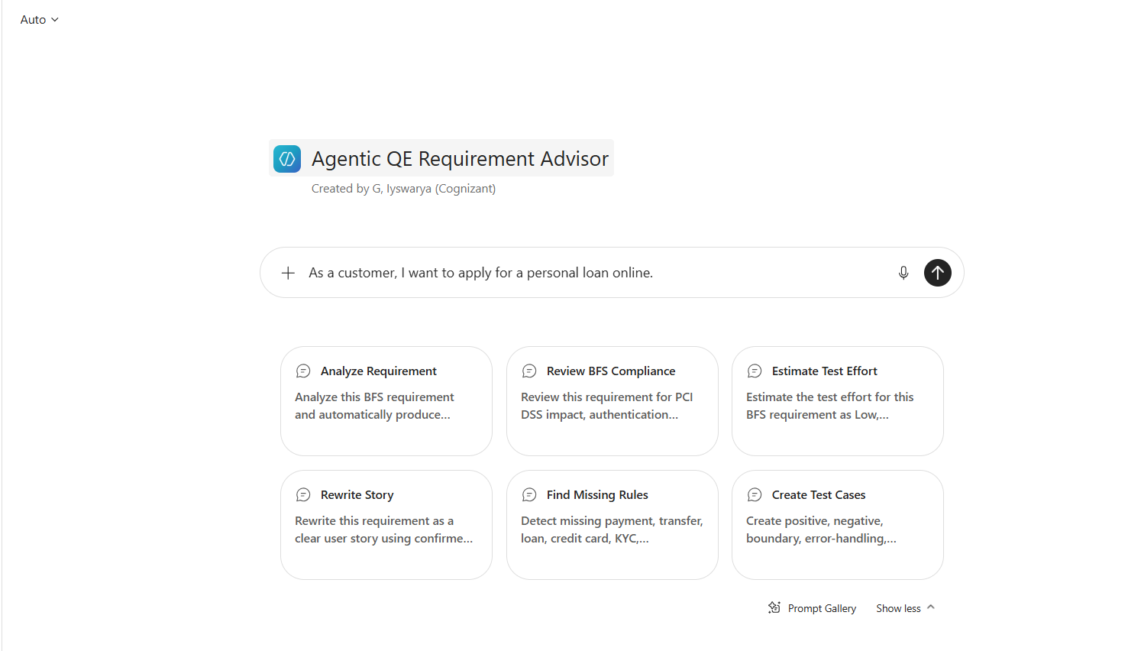
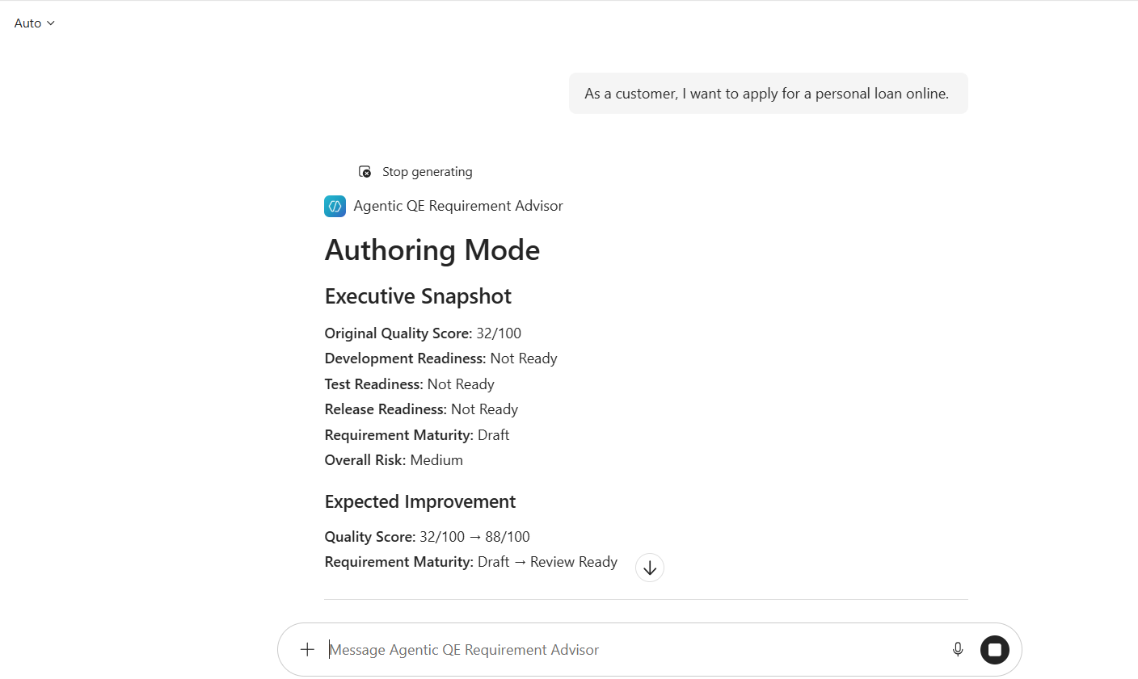

Companion application- Python Streamlit dashboard to visualize the same:
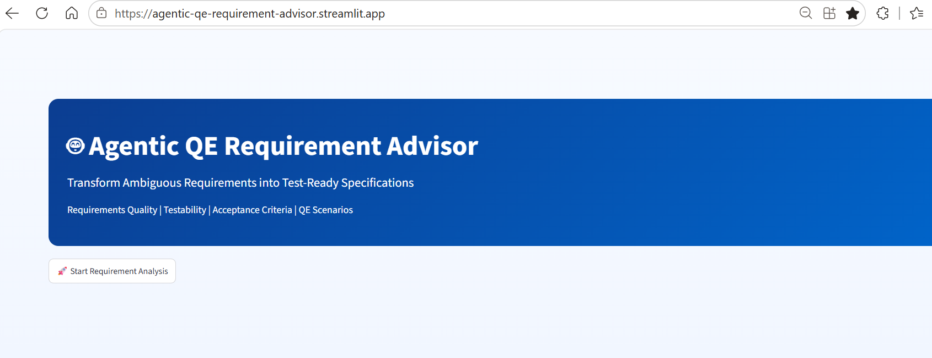
Click on the ‘Start Requirement Analysis’ from the Home page:
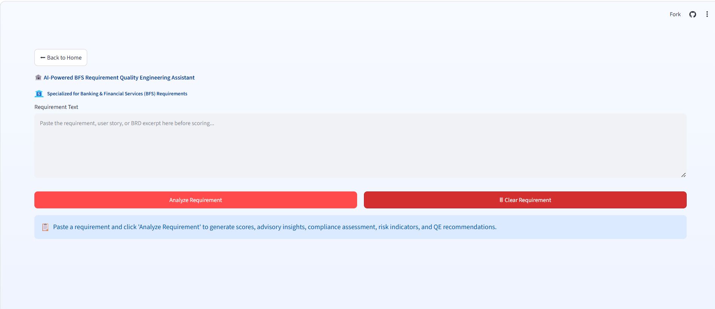
Input the requirement and Click on ‘Analyze requirement’:
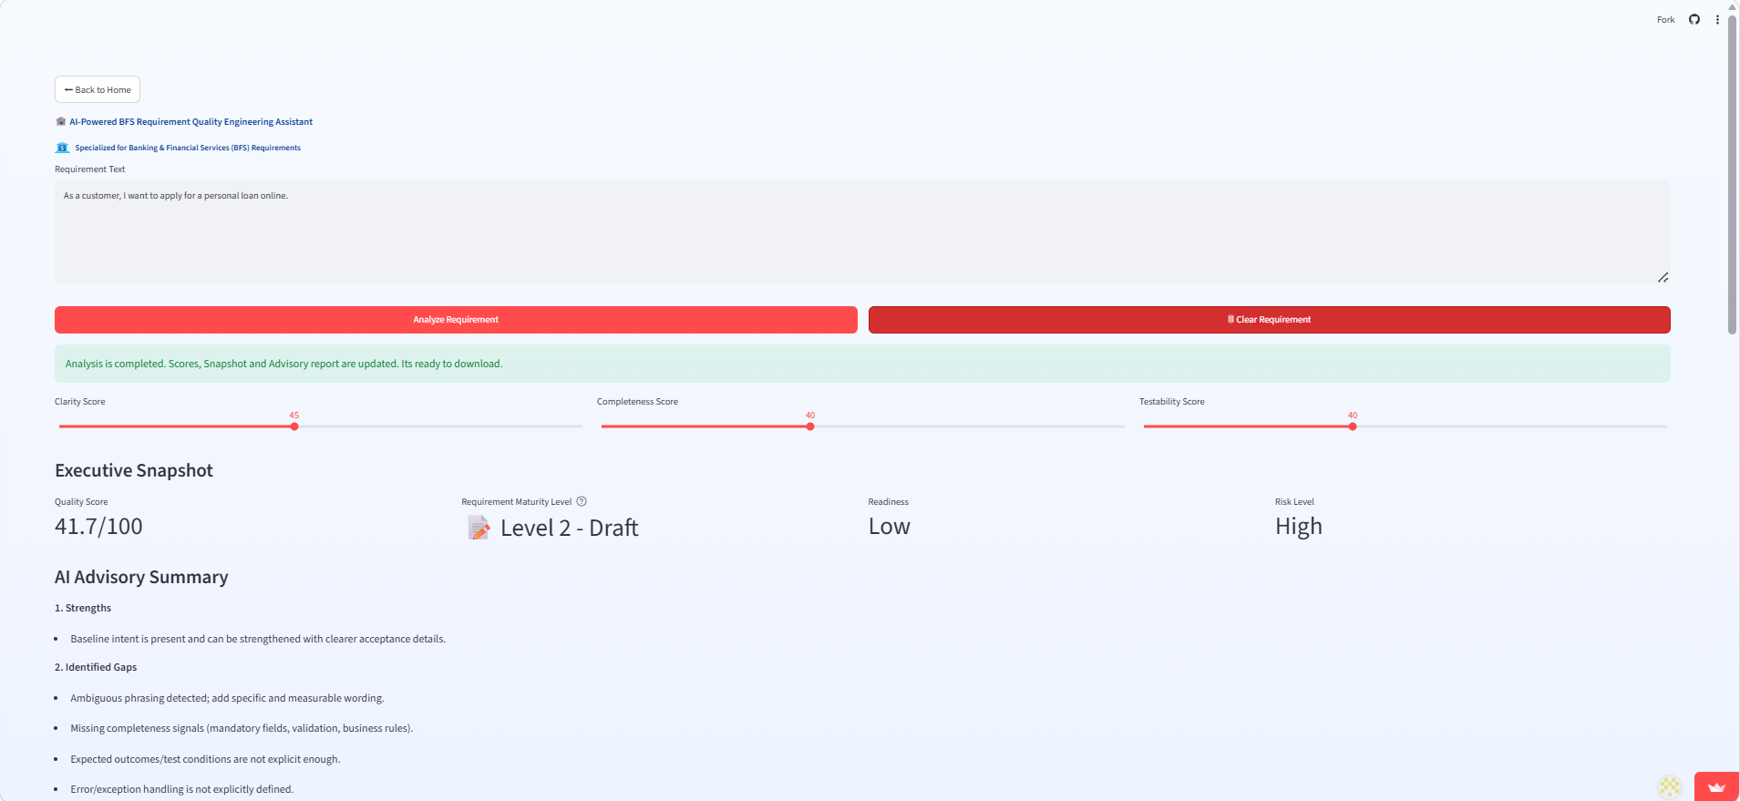
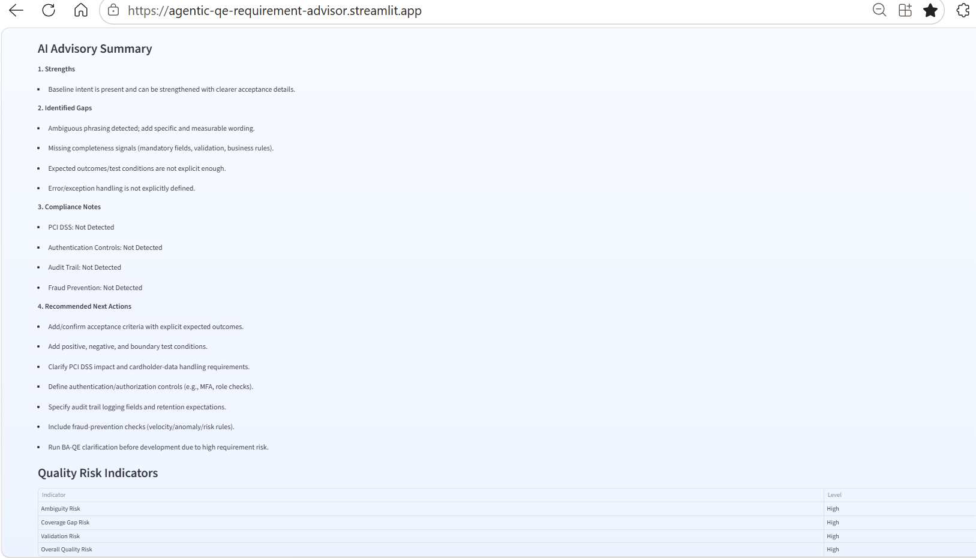
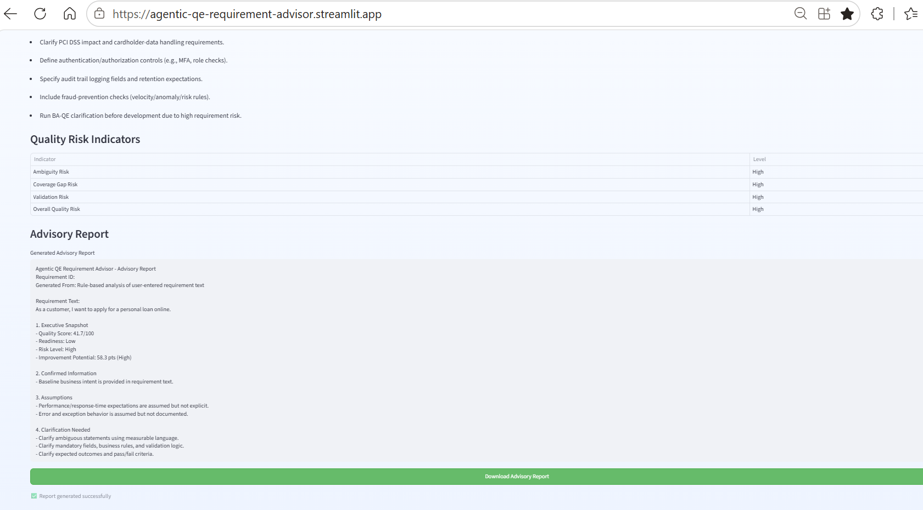
Attached sample output downloaded:

